✢ PEAL FOR THE HOLY WORKS ✢
HOLY ORTHODOX METROPOLIS OF MITYANA — UGANDA
“Bear one another’s burdens, and so fulfill the law of Christ.” — Galatians 6:2
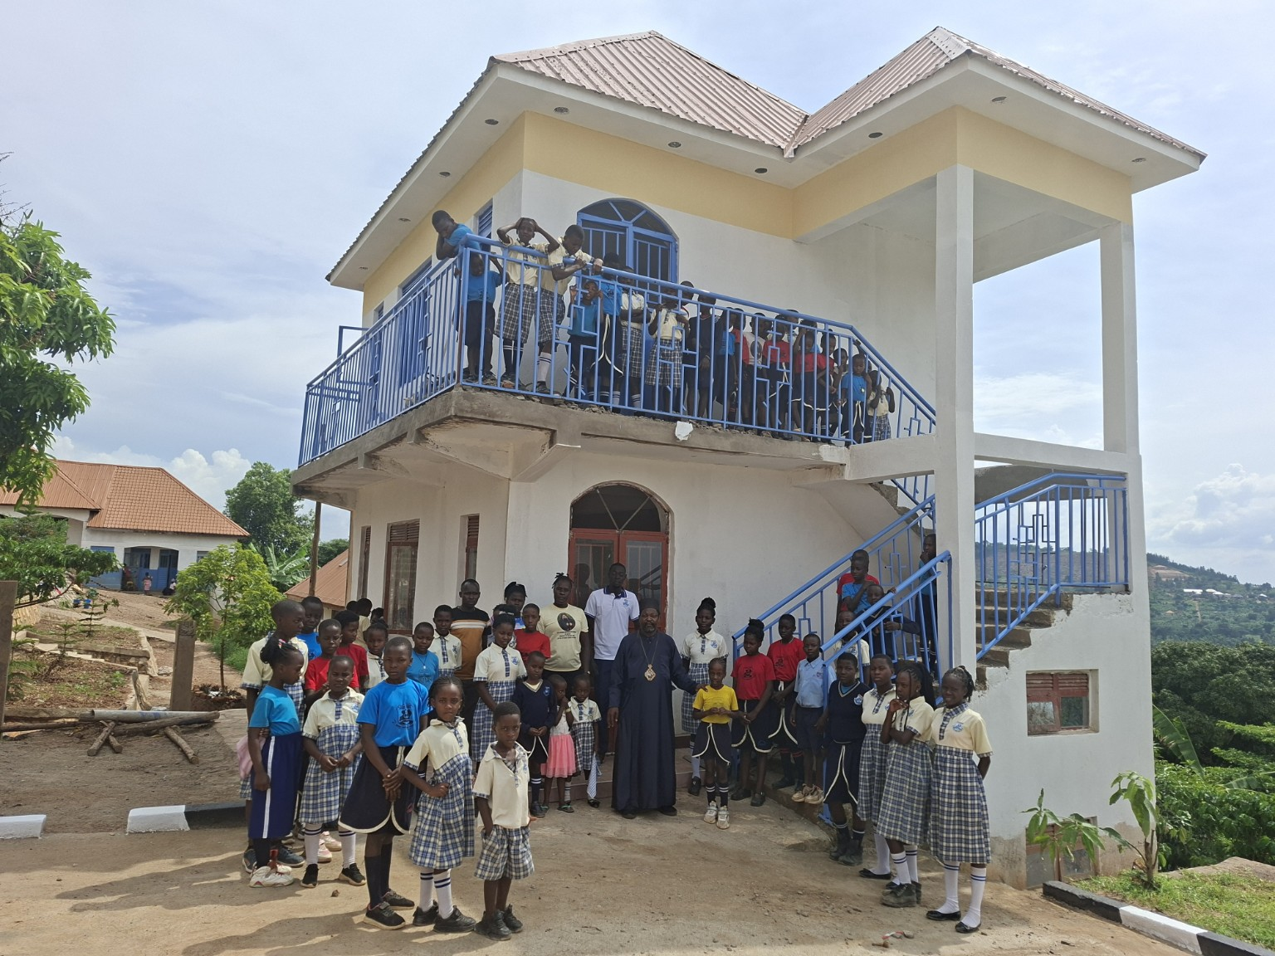
Children and members of the Metropolis community at one of our ministry sites.
Beloved in Christ, Your Beatitude, and dear friends and benefactors,
With hearts full of gratitude to God, the Holy Orthodox Metropolis of Mityana, Uganda, is preparing to celebrate the Feast of St. Nektarios the Wonderworker on 9/22 November 2026 at our Metropolis Cathedral. This joyous occasion will also mark the inauguration of our first pilgrimage with the faithful of Uganda.
We are profoundly grateful to Your Beatitude for the precious holy relic of St. Nektarios, which is a great spiritual blessing and a source of encouragement to our growing Orthodox community.
As our Metropolis continues its mission of spreading the Holy Orthodox Faith, educating children, forming future clergy, and caring for the sick and vulnerable, we humbly appeal to Your Beatitude and all our generous friends and benefactors for support towards five important projects.
OUR FIVE PRIORITY PROJECTS
PROJECT | AMOUNT | PURPOSE
1. St. Kosmas of Aetolia Church | USD 4,040 | Urgent roofing works to protect the church from heavy rains and provide the faithful with a safe and dignified place of worship.
2. St. Gregory Palamas Orthodox School | USD 2,162 | Construction of a new pit latrine to improve sanitation and safeguard the health, dignity, and well-being of our children and staff.
3. Clergy Formation and Training | USD 14,976 | Supporting the spiritual, theological, and pastoral formation of future clergy who will faithfully serve the Holy Church and her people.
4. St. Panteleimon Clinic | USD 3,820 | Providing essential medical equipment, medicines, furniture, and supplies to care for the sick, poor, and vulnerable.
5. Metropolis Cathedral Access Road | USD 4,040 | Improving the road leading to our Cathedral so that clergy, faithful, pilgrims, and visitors can reach the holy sanctuary more safely, especially during the rainy season.
TOTAL AMOUNT NEEDED: USD 29,038
YOUR GIFT CAN MAKE A DIFFERENCE!
Beloved brothers and sisters in Christ, every contribution, whether large or small, will help us advance these holy works. Your generosity will help protect a house of worship, provide better facilities for our children, prepare future servants of God, care for the sick, and make our Cathedral more accessible to pilgrims and worshippers.
We humbly invite individuals, parishes, monasteries, and friends of the Orthodox Church throughout the world to join us in this sacred mission. Kindly support us according to your ability, and please share this appeal with others who may wish to participate in these works of faith, love, and mercy.

THE WORK YOUR GENEROSITY WILL SUPPORT
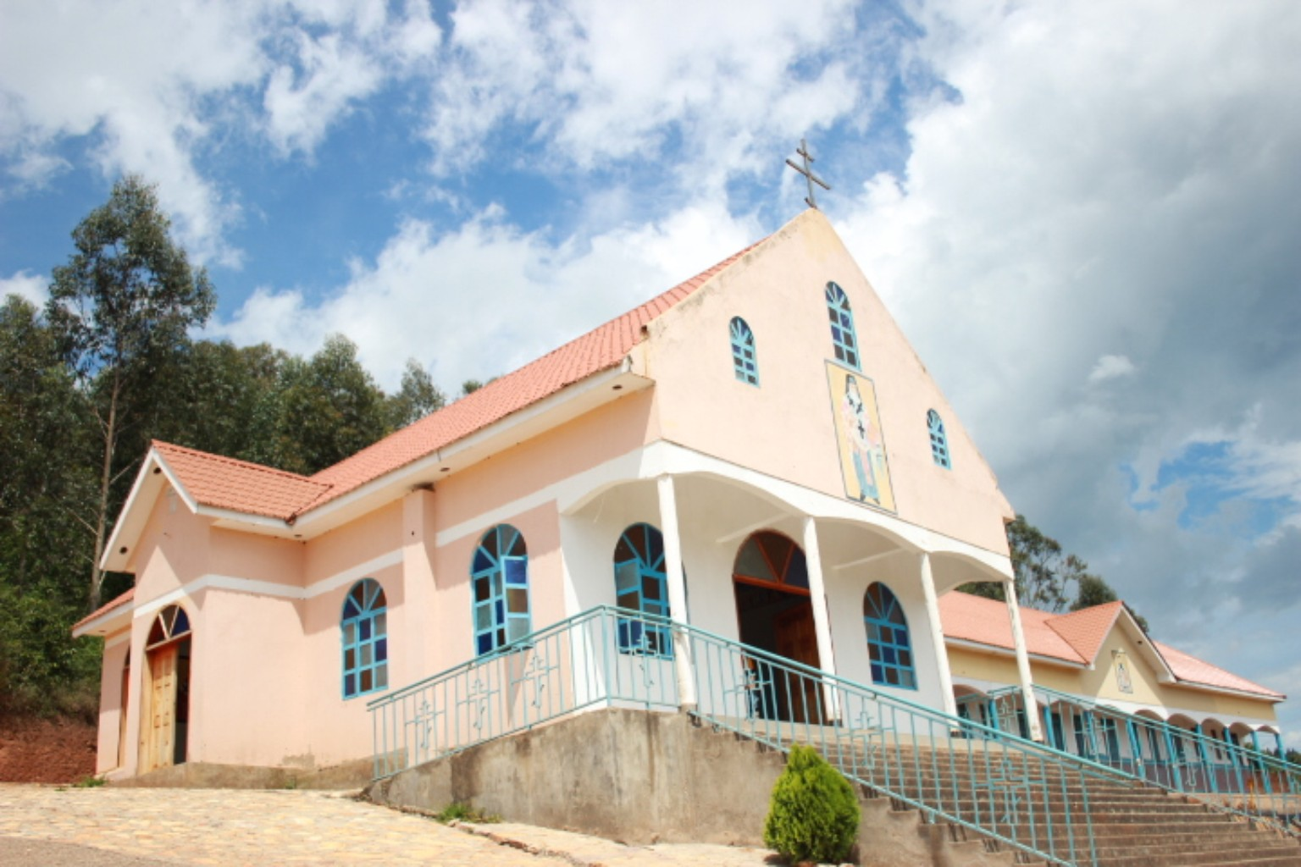
The Metropolis Cathedral — the spiritual home of our growing community.
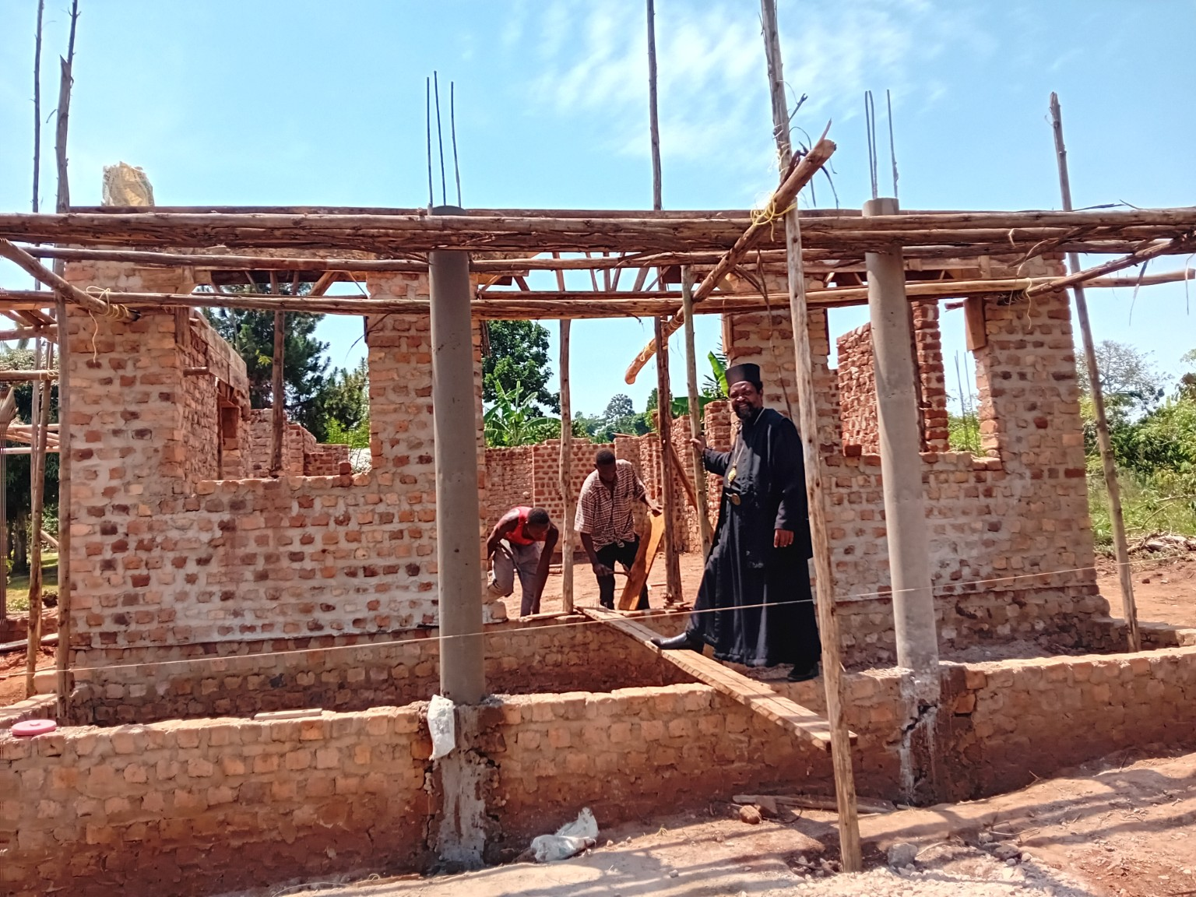
Church construction in progress: support will help complete essential works of worship.
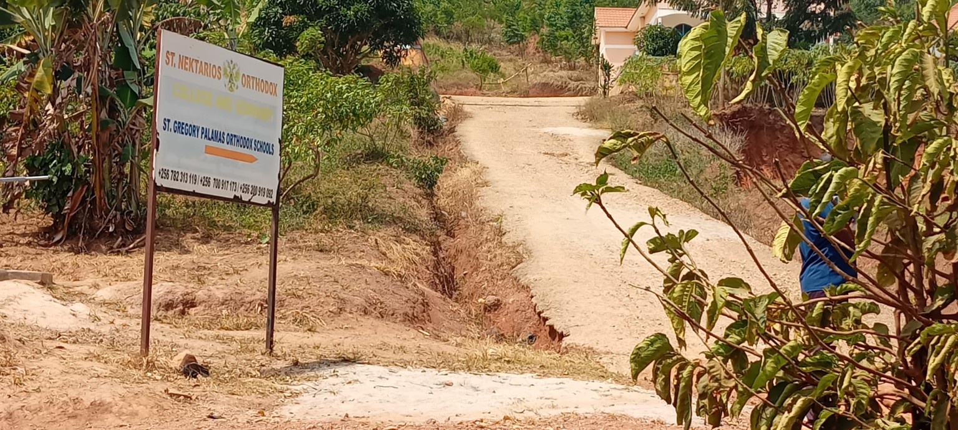
St. Nektarios Orthodox College and St. Gregory Palamas Orthodox Schools.

ACCESS FOR WORSHIP, LEARNING AND PILGRIMAGE
The Cathedral access road needs further improvement to make arrival safer and easier for clergy, children, parishioners, pilgrims and visitors, particularly during the rainy season.
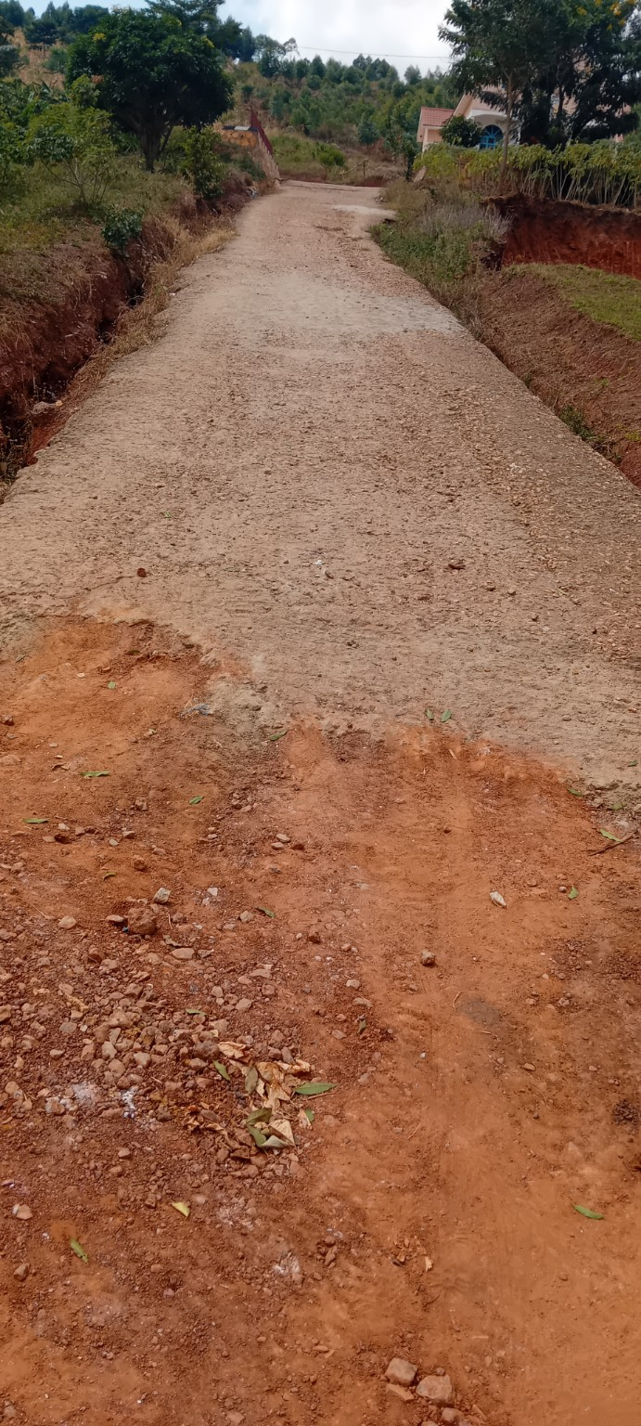
Current condition of the Cathedral access road.
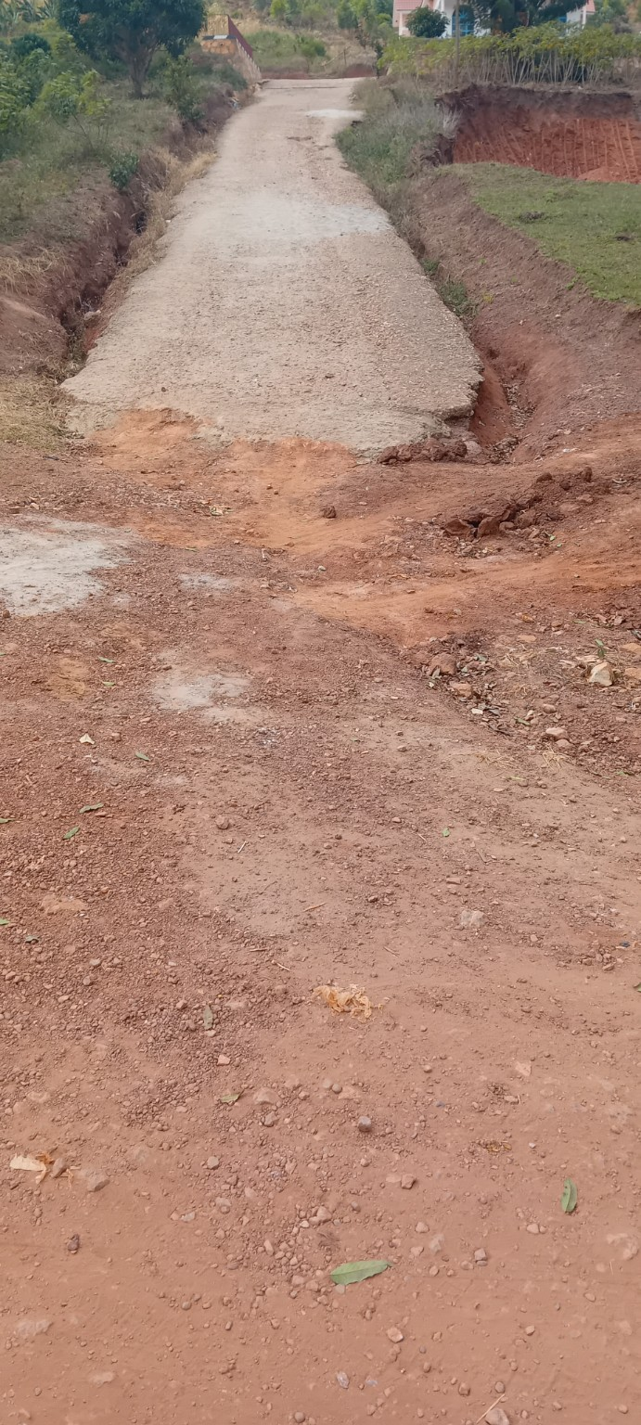
Drainage and surface improvements are important for safe access.
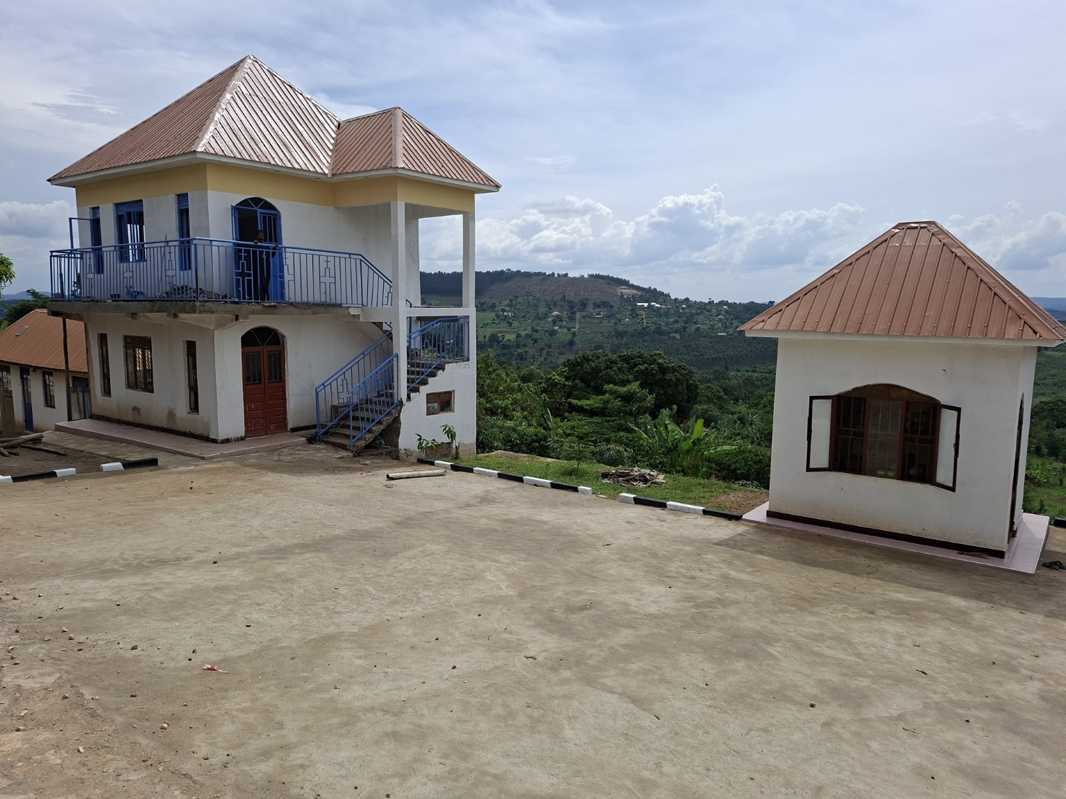
A view of the Metropolis facilities and surrounding grounds.
DONATIONS AND ENQUIRIES
Donation Contact: +256 707 502 097
Email: archbishoplubega@gmail.com
For further information about the projects or how to contribute, please contact us using the details above.
OFFICIAL BANK ACCOUNT DETAILS
BANK | ACCOUNT TITLE | ACCOUNT NUMBER | SWIFT CODE | CURRENCY
DTB | St. Nektarios Orthodox College and Seminary | 0209870004 | DTKEUGKA | USD
DTB | St. Nektarios Orthodox College and Seminary | 0209870001 | DTKEUGKA | UGX
Account Holder: St. Nektarios Orthodox College and Seminary. We kindly request benefactors to indicate the project they wish to support when making their contributions, where possible. This will help us direct donations towards the intended needs.
Through the holy intercessions of St. Nektarios the Wonderworker and St. Panteleimon, may our Lord Jesus Christ bless these works, strengthen all who labour in His vineyard, protect our children, comfort the sick, and richly reward every benefactor who gives with a generous heart.
May God bless you and your families for standing with us in this holy mission!

With filial gratitude, prayers, and every blessing in Christ Jesus,

✢ Archbishop Metropolitan Nektarios Leonard Lubega
; Ph.D
Metropolitan of Mityana and Exarch of Africa
HOLY ORTHODOX METROPOLIS OF MITYANA — UGANDA

